Primary Treatment
3.1. Facility Types
Primary treatment in this design is achieved using circular primary clarifiers. While both circular and rectangular clarifiers are widely used, circular tanks were selected due to their hydraulic efficiency, ease of sludge removal, and suitability for continuous operation in medium-to-large wastewater treatment plants. Circular clarifiers promote uniform radial flow distribution, reducing dead zones and short-circuiting, which enhances sedimentation performance. Mechanically, the rotating sludge scraper arms in circular clarifiers allow for reliable and consistent solids removal with minimal manual intervention. Moreover, for a greenfield development with expected long-term service and increasing population, circular clarifiers provide a scalable, space-efficient, and operationally robust solution.

3.2. Design Description

3.3. Pollutants

The removal efficiency for BOD and suspended soils (TSS) was determined based on the influent BOD5 concentration (370 mg/L) and the detention time required, having into account that lower temperatures affect directly the particles settlement velocity due to changes in the viscosity of the water (Metcalf & Eddy I AECOM, 2014). Likewise, the author mentions that the removal efficiency for BOD moves into the interval of 25 to 40 percent, for TSS is between 50 to 70 percent. The author presents the relationship between removal efficiency and detention time (Equation X), it is given by empirical constants at 20°C for BOD and TSS (Table X).
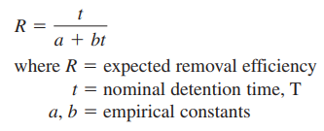
Equation X.
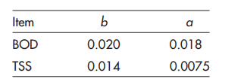
Table X. Empirical constants for removal efficiency of BOD and TSS.

The detention time (t) was determined by practicing several iterations that meets the efficiency requirements into this primary treatment stage and pointing to meet the efficiency requirements for the secondary treatments stage. To meet such requirements, the target of BOD removal efficiency was set in 30%. Further, the detention time (t) was adjusted using a security factor defined by the temperature conditions prevailing in the operation place. Metcalf & Eddy (2014) presents a curve to estimate such security factor needed to increase the detention time for temperatures lower than 20°C (Figure X).
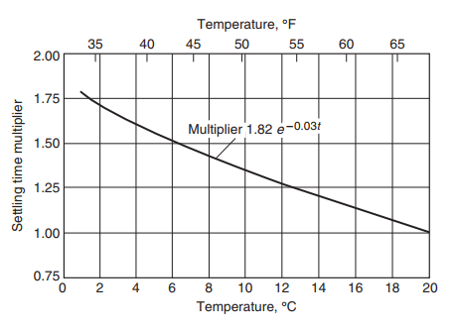
Figure X. Curve of increase in detention time required at lower temperatures, to achieve the same sedimentation performance in clarifiers at 20°C.

To meet all requirements for this stage of the primary treatment design it is necessary to evaluate the adjusted detention time is between the time interval of 1.5 hours and 2.5 hours. Below is presented the summary of the removal efficiency for BOD and TSS, and the adjusted detention time calculated.

Removal Efficiency for adjusted detention time of peak flow rate (t_PHR) at 10°C
Adjusted detention time (t_PHR) = 1.82h
R_BOD = 30.0% -> 25% < R_BOD < 40%
R_TSS = 51.14% -> 50% < R_TSS < 70%

Removal Efficiency for detention time of average dry weather flow (t_ADW) at 10°C
Detention time (t_ADW) = 2.50h
R_BOD = 33.66% -> 25% < R_BOD < 40%
R_TSS = 55.42% -> 50% < R_TSS < 70%

As was mentioned before, the removal efficiency must be calculated at 20°C temperature conditions. It means that the detention times presented above must be corrected dividing each one by the security factor corresponding to the temperature of 10°C. Finally, the greater BOD5 concentration at the end of the primary treatment is 259 mg/L. This BOD5 concentration will be treated during the secondary treatment.

Protection against failure
Below are presented key aspects related to the proposed design that ensure protection against failures of the relevant components for the primary treatment circular tanks:
- Redundancy: It was proposed three tanks to allow for independent operation and prevent complete system shutdown during maintenance or failure of at least one tank. (Davis, 2010)
- Hydraulic Load Management: The designed handles peak flows 2.2 times greater than the average flow minimize surges from recycle streams, protecting downstream processes from overload. (Davis
- Overflow Rates: The design maintains recommended SLR into the permissible range to ensure effective sedimentation and prevent solids washout (Davis, 2010). Also, it is possible to ensure that the peak flow is at least 2 times greater than the average flow (Metcalf and Eddy, 2019).
- Adequate Detention Time: The design ensures sufficient detention time (1.5h < t < 2.5h) to allow settling while preventing anaerobic conditions that can cause sludge lifting (Davis, 2010).
- Velocity Control: It is worth mentioning that the flow velocity will be limited within the tank to avoid resuspending settled solids (Davis, 2010).
- Effective Flow Distribution: The design contemplates utilizing well-designed inlets and baffles ahead of effluent weirs to distribute flow evenly, prevent short-circuiting, and promote settling; also preventing scum to discharge into the effluent (Metcalf & Eddy, 2019).
- Robust Sludge Removal: The design contemplates defining the bottom of the tank sloped 1 in 12 (vertical : horizontal) forming an inverted cone. Such sloped bottom and effective scrapers ensure to move settled sludge to the hopper (Metcalf & Eddy, 2019).

Reference
[Metcalf and Eddy, 2014] Metcalf & Eddy I AECOM. (2014). Wastewater engineering : treatment and resource recovery (5th ed.). McGraw-Hill Education.

